Home:


Instilling Confidence
Children are the pillars of tomorrow’s society. We make them knowledgeable and confident, strengthening those shoulders to carry the weight of the world.

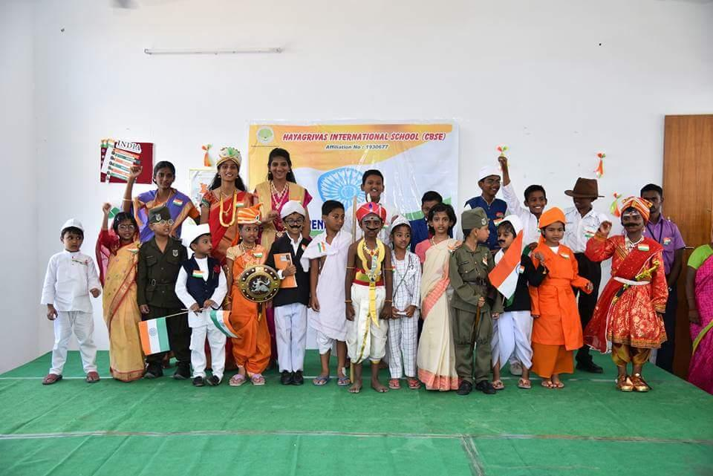
Teaching Responsibility
A child’s conscience is pure and godly. We impart values and ethics that they will carry with them through their life and be respected for them.

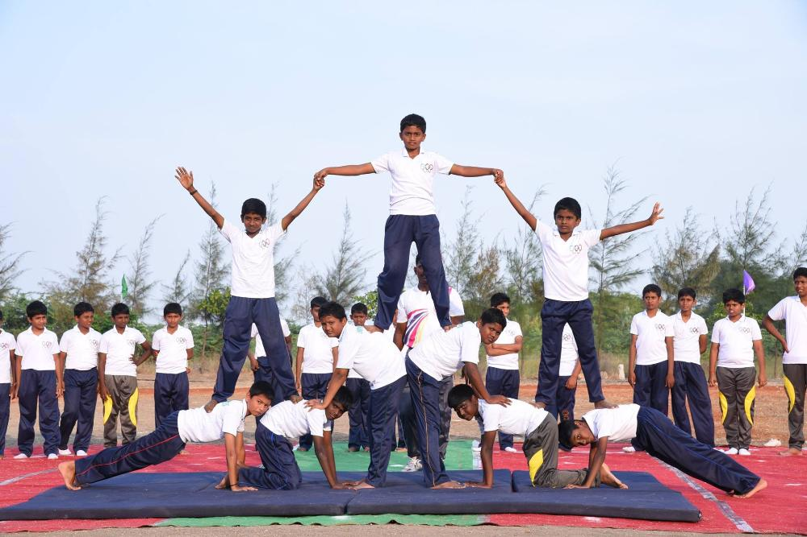
Nurturing enthusiasm
Children are curious. We nurture their curiosity and education to push the boundaries of learning and teaching beyond the conventional methods.

Academics
HAYAGRIVAS INTERNATIONAL SCHOOL follows CBSE curriculum with the guidance of NCERT supplied material and some books from leading publishers for guidance. The School also adheres to Continuous and Comprehensive Evaluation (CCE) under the guidance of Central Board of Secondary Education (CBSE), Delhi.
Exam Pattern, Evaluation Pattern, Formative and Summative Assessments are followed as per CBSE directions and guidelines. Periodic tests and Assessments are being conducted for each student from time to time. Each student is supplied Annual Academic Calendar well in advance so that they can plan their holidays. The School celebrates almost all the functions inside the campus to give knowledge to our generation about our rich culture.
HAYAGRIVAS encouraged all the students from Class.1 to appear National Science Olympiad (NSO), International English Olympiad (IEO) , International Mathematics Olympiad (IMO) and International French Olympiad (IFO).
Most Prestigious award from British council is awarded as International School Award(ISA)due to the energetic effort of OUR TEAM.
We treat English as a first language and Hindi/Tamil as a second language for all the classes. Hindi is a compulsory second language for the students who joined from Kinder Garten. We maintain 100% English speaking ambience and importance will be given to enhance the leadership skills of the students.
First and third Saturdays of every month are being dedicated to co curricular activities (CCA) where the students are not needed to carry books(No Book Day). All the students are taken for enjoyable tour once in a year in addition to the field trips.
The academic session starts from April to March. The vacation period starts from the last week of March till the end of May. The admission starts from January onwards and ends at the middle of April.

Management
HAYAGRIVAS INTERNATIONAL SCHOOL is run by the TRUST called Sree Hayagrivas Educational Trust., The Board of Trustees having good academic background and attitude to serve the public.
HAYAGRIVAS has constructive mission and vision to carry out the objectives of CBSE education in the town as well as sub urban area.
The Board of Trustees pledged to offer better education at par with Schools in City. The Trustees set their goal to spread CBSE education across the area and implemented a new trend in administration which reveals real International standards.
Chairman Speaks
“HAYAGRIVAS shall provide quality education for all the children to attain the highest academic standards. We maintain strong work ethos. We always believe in honesty and fairness. The real School is the one which creates an environment for each student to discover and realize his/her full potential. We shall inculcate a spirit of inquiry and adventure amongst students”
- Jayakumar, Correspondent
“We, the Management of HAYAGRIVAS is committed to provide the best education to our esteemed society. Education is only the most excellent way to shape human behaviour. HAYAGRIVAS is devoted to offer holistic education irrespective race, religion, region etc. School is the only place where a student learns the values of society. HAYAGRIVAS welcomes you all to participate in collective work towards the growth of our society”
- Vengadesh prasath, President
“HAYAGRIVAS aims to be an Institution of excellence dedicated to produce leaders of tomorrow. The role of School is not just ended up with good education also in nurturing them as good citizen of our society. We believe in the ethical values and we focus more on harvesting the talents, not the money. We assure to create an awareness and understanding of country’s rich culture, human rights and democratic values”
- Gnana Subbiah, Trustee
HAYAGRIVAS INTERNATIONAL SCHOOL
HAYAGRIVAS International School (CBSE), a truly international School environment dedicated to excellence in education - Established in 2010 - Run by Sree Hayagrivas Educational Trust
WHY HAYAGRIVAS?
- Nurturing the leaders of tomorrow
- Single handed and transparent Management
- Trained and Dedicated Teachers
- Management with good Vision and Mission
- Collaboration with many leading Competitive Exam Authorities
- Excellent Infrastructure
- High care in Safety and Security
- English Speaking Ambience
- Strict in Rules and Regulations.
- Personal Care and Attention
- Skill sheets to improve Skills of the Students
- Best Co Curricular Activities
- Participation in Competitions outside
- Excellent Public Speaking Skills
- Frequent IQ Tests - Adaptable to Latest Trends
- Freedom to Think, Express and Work
- Creative Teachers and Management
- Our Student becomes a innovative and independent Boy/Girl
- Proven Track Record
- Good Discipline
- Social Responsibility.
HONOUR. INTELLECT. SUCCESS.

Admission
The admissions start from January onwards. The admissions procedures are as per CBSE guidelines. To get into KG.I (LKG), a child must have completed 3 years and 6 Months of age as on 31,March of the year in which the child is seeking for admission.
Priority in admission even after the last date will be given to the Central Government, Public Sector Unit (PSU) employees and NRIs but the child must have studied CBSE in the previous year.
The School follows CBSE pattern of education with the help of NCERT books and some books from leading publishers for guidance. The School ensures Continuous and Comprehensive Evaluation (CCE) system and has semester system of calendar. We are giving training to teacher about updated CCE from time to time.
Each student is supplied Annual Academic Calendar well in advance so that they can plan their holidays. The School celebrates almost all the functions inside the campus to give knowledge to our generation about our rich culture.
The academic session starts from April to March. The vacation period starts from the first week of May till end of the same month.
Contact
Office | Mobile | Email
04562-207272 / 207373 | 7373744882 / 7373744941 / 7373744883 | admin@hayagrivascbse.com
Online Enquiry Form

Infrastructure
The Infrastructure details are provided here as per the CBSE documents submitted by the School in the year 2012 and also based on the current situation/information.
School Area (in acres) | : 02.03 acres
School Area (in sq.mt.) | : 21347.16 sq.mt
Built up area (metre) (approx.) | : 5574.18 / 60000 sq.ft

Area of the Play ground (in acres) | : 03.00 acres
Laboratory | : Separate Physics, Chemistry, Biology Labs & Bill Gates Computer Lab, ATAL tinkering lab
Library | : Around 5000 books
Affliation Details
Name & Address of the School | : Hayagrivas International School  Hayagrivas Gardens  Pernayakkanpatti  Sivakasi -626189  Virudhunagar - Dist. Tamil Nadu
Year of Establishment | : 2012
NOC Detail | : Issued by : Government of Tamil Nadu  NOC No. : K.Dis.No.95497/G1/S1/2015  Dated : 22 - 12 - 2015
CBSE Affiliation | : Affiliation No.1930677  Provisional Affiliation up to Senior Secondary Level
Run by | : Sree Hayagrivas Educational Trust  52, A.S.K.Thangiah Nadar Road  Sivakasi- 626189
List of Trustees | : 1. Mr. G.Jayakumar - Managing Trustee  2. Mr. G.Vengadesh Prasad - Trustee  3. Mr. S.Gnana Subbiah- Trustee  4. Mr. R.Padmakumar - Trustee
Chairman & Correspondent | : Mr. G.Jayakumar

Address
Hayagrivas International school (CBSE)
Hayagrivas Gardens
Pernaickenpatti
Sivakasi 626189
Email: admin@hayagrivascbse.com
Mob. No. 7373744882 / 7373744941 / 7373744882

CBSE AFFILIATION No: 1930677
© 2017. All rights reserved.

